The YES (Youth Employment Services) program of Tuscarawas County is now accepting applications for enrollment into a paid classroom and work experience training program. If you are 16-24 years old and would like a chance to start shaping your future, call today to set up an appointment with a YES staff member.
**Eligibility requirements do apply.

The YES program assists with setting career goals (GED/College/Worksites), resume writing, interviewing skills, financial budgeting, leadership development and work experience, all while getting paid.

Student must be willing to commit to program classes, obtaining GED/Diploma (if needed) and gainful employment at the conclusion of the program.
Call: 330-432-8515 or
Email: yes@harcatus.org
YES of Tuscarawas County
WHY YES?
Scheduled work and classroom hours
Paid work and classroom experience
Supportive services such as transportation, work-related clothing and equipment
Leadership Experiences/Community Engagements
Financial Literacy (present and future planning)
Resume Writing and Interviewing Skills Training
Incentives when you meet your goals
Staff follow-up to assist you on your career path
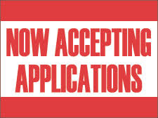
**Eligibility requirements do apply
This program is funded by Workforce Initiative Association through Grants from Employment and Training Division of the Department of Labor.

